

Family Engagement Plan for Pre-Kindergarten

Early Childhood – ELAR Department

2022-2023

Parental involvement plays a large factor in early childhood student success. In order to support parents and provide them with ideas and strategies to support their child’s literacy achievement, DISD hosted the following series of sessions for parents during the 2022-2023 school year.

These sessions were developed around materials from “Partners in Print,” a parent-involvement program for beginning readers. The aim of this program is to educate and empower parents so they can help develop their children’s literacy and encourage partnership between parents, teachers, and children.

The dates and times for the 2022-2023 school year were as follows (some campuses made adjustments to the dates and still covered the topics). The hours for the sessions were 5:30-6:30 p.m. at each respective campus.

* September 29th – Opening Night (Program Introduction), 5:30 p.m.-6:30 p.m.
* November 10th – Build Self-Esteem
* December 14th – Drawing Meaning from Text
* February 16th – Playing with Print
* March 23rd – Conventions of Print
* April 20th – Writing
* May 17th – Grand Finale

**BOARD OF TRUSTEES**

**David De Los Rios**

President

**Jose L. Valdez**

Vice-President

**Fernando Castillo**

Secretary

**Members**

Lt (Col.) Robert Perez

Jose Rogelio Reyna Jr.

Dr. Maricela Valdez

Eva Castillo Watts

**ADMINISTRATION**

**Angela Dominguez**

Superintendent of Schools

**Adela G. Troncoso**

Assistant Superintendent for Human Resources

**Rebecca Castaneda**

Assistant Superintendent for Leadership

**Rashad J. Rana**

Assistant Superintendent for Educational Services

**Alfonso Perez**

Assistant Superintendent for Business and Finance

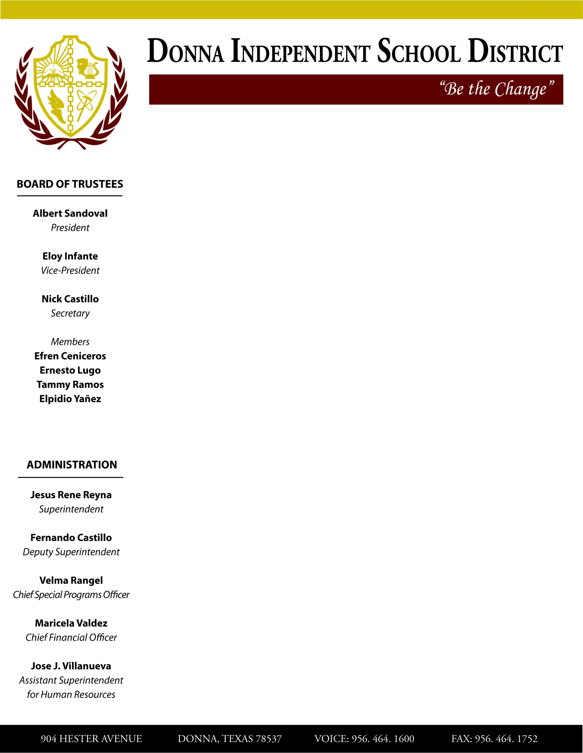

904 HESTER AVENUE DONNA, TEXAS 78537 VOICE: 956-464-1600 FAX: 956-464-17522